**Final Project summary**

**Credit Card Billing System**

**Group: Final Project 100**

Balaji Gewini Vijayabaskar

Nagalakshmi Cherukuri

/*

** Author: Balaji Gewini Vijayabaskar, Nagalakshmi Cherukuri

** Course: IFT/530

** SQL Server Version: Microsoft SQL Server 2022(RTM)

** History

** Date Created Comments

** 04/30/2025 Credit Card Billing System (Final Project)

*/

‘Create database’

‘Create the tables using SQL script you have defined in the Final project.’

‘Code:’

/*

** Author: Balaji Gewini Vijayabaskar, Nagalakshmi Cherukuri

** Course: IFT/530

** SQL Server Version: Microsoft SQL Server 2022(RTM)

** History

** Date Created Comments

** 04/30/2025 Credit Card Billing System (Final Project)

*/

CREATE DATABASE Final_Project_100;

USE Final_Project_100;

-- Drop existing tables in dependency order

IF EXISTS (SELECT * FROM sysobjects WHERE id = OBJECT_ID('LateFees') AND xtype = 'U')

DROP TABLE LateFees;

IF EXISTS (SELECT * FROM sysobjects WHERE id = OBJECT_ID('Payments') AND xtype = 'U')

DROP TABLE Payments;

IF EXISTS (SELECT * FROM sysobjects WHERE id = OBJECT_ID('BillingStatements') AND xtype = 'U')

DROP TABLE BillingStatements;

IF EXISTS (SELECT * FROM sysobjects WHERE id = OBJECT_ID('Transactions') AND xtype = 'U')

DROP TABLE Transactions;

IF EXISTS (SELECT * FROM sysobjects WHERE id = OBJECT_ID('Rewards') AND xtype = 'U')

DROP TABLE Rewards;

IF EXISTS (SELECT * FROM sysobjects WHERE id = OBJECT_ID('CreditCards') AND xtype = 'U')

DROP TABLE CreditCards;

IF EXISTS (SELECT * FROM sysobjects WHERE id = OBJECT_ID('Customers') AND xtype = 'U')

DROP TABLE Customers;

-- Customers Table

CREATE TABLE Customers (

customer_id INT IDENTITY(1,1) PRIMARY KEY,

full_name VARCHAR(100) NOT NULL,

phone VARCHAR(15) NOT NULL UNIQUE,

email VARCHAR(100),

address VARCHAR(300)

);

-- CreditCards Table

CREATE TABLE CreditCards (

card_id INT IDENTITY(1,1) PRIMARY KEY,

customer_id INT NOT NULL,

card_number VARCHAR(16) NOT NULL UNIQUE,

card_type VARCHAR(20) NOT NULL CHECK (card_type IN ('Visa', 'MasterCard', 'Amex')),

credit_limit DECIMAL(10,2) NOT NULL,

expiry_date DATE NOT NULL,

FOREIGN KEY (customer_id) REFERENCES Customers(customer_id)

);

-- Transactions Table (Fact Table)

CREATE TABLE Transactions (

txn_id INT IDENTITY(1,1) PRIMARY KEY,

card_id INT NOT NULL,

txn_date DATETIME NOT NULL,

merchant_name VARCHAR(100) NOT NULL,

amount DECIMAL(10,2) NOT NULL CHECK (amount >= 0),

txn_type VARCHAR(15) NOT NULL CHECK (txn_type IN ('DEBIT', 'REFUND')),

FOREIGN KEY (card_id) REFERENCES CreditCards(card_id)

);

-- BillingStatements Table (Fact Table)

CREATE TABLE BillingStatements (

statement_id INT IDENTITY(1,1) PRIMARY KEY,

card_id INT NOT NULL,

billing_period VARCHAR(20) NOT NULL,

total_due DECIMAL(10,2) NOT NULL,

due_date DATE NOT NULL,

min_due DECIMAL(10,2) NOT NULL,

generated_on DATE NOT NULL,

FOREIGN KEY (card_id) REFERENCES CreditCards(card_id)

);

-- Payments Table

CREATE TABLE Payments (

payment_id INT IDENTITY(1,1) PRIMARY KEY,

statement_id INT NOT NULL,

paid_on DATE NOT NULL,

paid_amount DECIMAL(10,2) NOT NULL CHECK (paid_amount >= 0),

payment_method VARCHAR(50) NOT NULL,

FOREIGN KEY (statement_id) REFERENCES BillingStatements(statement_id)

);

-- LateFees Table

CREATE TABLE LateFees (

fee_id INT IDENTITY(1,1) PRIMARY KEY,

statement_id INT NOT NULL,

fee_amount DECIMAL(10,2) NOT NULL,

reason VARCHAR(200) NOT NULL,

applied_on DATE NOT NULL,

FOREIGN KEY (statement_id) REFERENCES BillingStatements(statement_id)

);

-- Rewards Table

-- Rewards Table

CREATE TABLE Rewards (

reward_id INT IDENTITY(1,1) PRIMARY KEY,

card_id INT NOT NULL,

points_earned INT NOT NULL DEFAULT 0,

points_redeemed INT NOT NULL DEFAULT 0,

last_updated DATE NOT NULL,

FOREIGN KEY (card_id) REFERENCES CreditCards(card_id)

);

‘Image:’

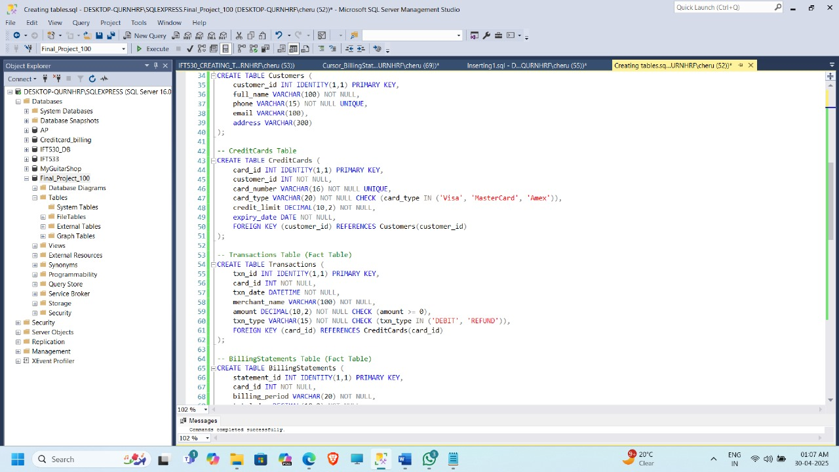

‘Generate the ERD diagram and paste it in a word document.’

‘Image’

‘Populate the table:’

‘code:’

/*

** Author: Balaji Gewini Vijayabaskar, Nagalakshmi Cherukuri

** Course: IFT/530

** SQL Server Version: Microsoft SQL Server 2022(RTM)

** History

** Date Created Comments

** 04/30/2025 Credit Card Billing System (Final Project)

*/

use Final_Project_100;

INSERT INTO Customers (full_name, phone, email, address) VALUES ('Customer 1', '9876543201', 'customer1@mail.com', '1 Main St, City');

INSERT INTO Customers (full_name, phone, email, address) VALUES ('Customer 2', '9876543202', 'customer2@mail.com', '2 Main St, City');

INSERT INTO Customers (full_name, phone, email, address) VALUES ('Customer 3', '9876543203', 'customer3@mail.com', '3 Main St, City');

INSERT INTO Customers (full_name, phone, email, address) VALUES ('Customer 4', '9876543204', 'customer4@mail.com', '4 Main St, City');

INSERT INTO Customers (full_name, phone, email, address) VALUES ('Customer 5', '9876543205', 'customer5@mail.com', '5 Main St, City');

INSERT INTO Customers (full_name, phone, email, address) VALUES ('Customer 6', '9876543206', 'customer6@mail.com', '6 Main St, City');

INSERT INTO Customers (full_name, phone, email, address) VALUES ('Customer 7', '9876543207', 'customer7@mail.com', '7 Main St, City');

INSERT INTO Customers (full_name, phone, email, address) VALUES ('Customer 8', '9876543208', 'customer8@mail.com', '8 Main St, City');

INSERT INTO Customers (full_name, phone, email, address) VALUES ('Customer 9', '9876543209', 'customer9@mail.com', '9 Main St, City');

INSERT INTO Customers (full_name, phone, email, address) VALUES ('Customer 10', '9876543210', 'customer10@mail.com', '10 Main St, City');

INSERT INTO CreditCards (customer_id, card_number, card_type, credit_limit, expiry_date) VALUES (1, '4111111111111101', 'Visa', 8385, '2027-12-31');

INSERT INTO CreditCards (customer_id, card_number, card_type, credit_limit, expiry_date) VALUES (2, '4111111111111102', 'Amex', 8354, '2027-12-31');

INSERT INTO CreditCards (customer_id, card_number, card_type, credit_limit, expiry_date) VALUES (3, '4111111111111103', 'Visa', 2904, '2027-12-31');

INSERT INTO CreditCards (customer_id, card_number, card_type, credit_limit, expiry_date) VALUES (4, '4111111111111104', 'Amex', 9402, '2027-12-31');

INSERT INTO CreditCards (customer_id, card_number, card_type, credit_limit, expiry_date) VALUES (5, '4111111111111105', 'Visa', 6966, '2027-12-31');

INSERT INTO CreditCards (customer_id, card_number, card_type, credit_limit, expiry_date) VALUES (6, '4111111111111106', 'MasterCard', 3473, '2027-12-31');

INSERT INTO CreditCards (customer_id, card_number, card_type, credit_limit, expiry_date) VALUES (7, '4111111111111107', 'Amex', 3907, '2027-12-31');

INSERT INTO CreditCards (customer_id, card_number, card_type, credit_limit, expiry_date) VALUES (8, '4111111111111108', 'MasterCard', 6853, '2027-12-31');

INSERT INTO CreditCards (customer_id, card_number, card_type, credit_limit, expiry_date) VALUES (9, '4111111111111109', 'MasterCard', 2179, '2027-12-31');

INSERT INTO CreditCards (customer_id, card_number, card_type, credit_limit, expiry_date) VALUES (10, '4111111111111110', 'MasterCard', 5876, '2027-12-31');

INSERT INTO Transactions (card_id, txn_date, merchant_name, amount, txn_type) VALUES (7, '2025-04-02 00:00:00', 'Merchant 1', 110.59, 'REFUND');

INSERT INTO Transactions (card_id, txn_date, merchant_name, amount, txn_type) VALUES (10, '2025-04-03 00:00:00', 'Merchant 2', 94.48, 'REFUND');

INSERT INTO Transactions (card_id, txn_date, merchant_name, amount, txn_type) VALUES (3, '2025-04-04 00:00:00', 'Merchant 3', 166.04, 'REFUND');

INSERT INTO Transactions (card_id, txn_date, merchant_name, amount, txn_type) VALUES (8, '2025-04-05 00:00:00', 'Merchant 4', 75.84, 'REFUND');

INSERT INTO Transactions (card_id, txn_date, merchant_name, amount, txn_type) VALUES (10, '2025-04-06 00:00:00', 'Merchant 5', 175.48, 'DEBIT');

INSERT INTO Transactions (card_id, txn_date, merchant_name, amount, txn_type) VALUES (1, '2025-04-07 00:00:00', 'Merchant 6', 273.88, 'DEBIT');

INSERT INTO Transactions (card_id, txn_date, merchant_name, amount, txn_type) VALUES (10, '2025-04-08 00:00:00', 'Merchant 7', 207.64, 'REFUND');

INSERT INTO Transactions (card_id, txn_date, merchant_name, amount, txn_type) VALUES (3, '2025-04-09 00:00:00', 'Merchant 8', 128.99, 'DEBIT');

INSERT INTO Transactions (card_id, txn_date, merchant_name, amount, txn_type) VALUES (9, '2025-04-10 00:00:00', 'Merchant 9', 396.19, 'REFUND');

INSERT INTO Transactions (card_id, txn_date, merchant_name, amount, txn_type) VALUES (8, '2025-04-11 00:00:00', 'Merchant 10', 131.93, 'DEBIT');

INSERT INTO Transactions (card_id, txn_date, merchant_name, amount, txn_type) VALUES (9, '2025-04-12 00:00:00', 'Merchant 11', 113.53, 'REFUND');

INSERT INTO Transactions (card_id, txn_date, merchant_name, amount, txn_type) VALUES (4, '2025-04-13 00:00:00', 'Merchant 12', 58.06, 'REFUND');

INSERT INTO Transactions (card_id, txn_date, merchant_name, amount, txn_type) VALUES (3, '2025-04-14 00:00:00', 'Merchant 13', 486.93, 'REFUND');

INSERT INTO Transactions (card_id, txn_date, merchant_name, amount, txn_type) VALUES (4, '2025-04-15 00:00:00', 'Merchant 14', 116.3, 'DEBIT');

INSERT INTO Transactions (card_id, txn_date, merchant_name, amount, txn_type) VALUES (3, '2025-04-16 00:00:00', 'Merchant 15', 452.32, 'REFUND');

INSERT INTO Transactions (card_id, txn_date, merchant_name, amount, txn_type) VALUES (3, '2025-04-17 00:00:00', 'Merchant 16', 363.77, 'REFUND');

INSERT INTO Transactions (card_id, txn_date, merchant_name, amount, txn_type) VALUES (2, '2025-04-18 00:00:00', 'Merchant 17', 223.39, 'REFUND');

INSERT INTO Transactions (card_id, txn_date, merchant_name, amount, txn_type) VALUES (4, '2025-04-19 00:00:00', 'Merchant 18', 79.01, 'DEBIT');

INSERT INTO Transactions (card_id, txn_date, merchant_name, amount, txn_type) VALUES (1, '2025-04-20 00:00:00', 'Merchant 19', 109.64, 'DEBIT');

INSERT INTO Transactions (card_id, txn_date, merchant_name, amount, txn_type) VALUES (4, '2025-04-21 00:00:00', 'Merchant 20', 494.36, 'DEBIT');

INSERT INTO BillingStatements (card_id, billing_period, total_due, due_date, min_due, generated_on) VALUES (1, 'Apr 2025', 105.51, '2025-04-25', 39.54, '2025-04-01');

INSERT INTO BillingStatements (card_id, billing_period, total_due, due_date, min_due, generated_on) VALUES (2, 'Apr 2025', 642.87, '2025-04-25', 66.23, '2025-04-01');

INSERT INTO BillingStatements (card_id, billing_period, total_due, due_date, min_due, generated_on) VALUES (3, 'Apr 2025', 389.84, '2025-04-25', 57.37, '2025-04-01');

INSERT INTO BillingStatements (card_id, billing_period, total_due, due_date, min_due, generated_on) VALUES (4, 'Apr 2025', 560.19, '2025-04-25', 76.61, '2025-04-01');

INSERT INTO BillingStatements (card_id, billing_period, total_due, due_date, min_due, generated_on) VALUES (5, 'Apr 2025', 896.66, '2025-04-25', 62.57, '2025-04-01');

INSERT INTO BillingStatements (card_id, billing_period, total_due, due_date, min_due, generated_on) VALUES (6, 'Apr 2025', 718.33, '2025-04-25', 99.07, '2025-04-01');

INSERT INTO BillingStatements (card_id, billing_period, total_due, due_date, min_due, generated_on) VALUES (7, 'Apr 2025', 640.49, '2025-04-25', 53.78, '2025-04-01');

INSERT INTO BillingStatements (card_id, billing_period, total_due, due_date, min_due, generated_on) VALUES (8, 'Apr 2025', 179.92, '2025-04-25', 29.28, '2025-04-01');

INSERT INTO BillingStatements (card_id, billing_period, total_due, due_date, min_due, generated_on) VALUES (9, 'Apr 2025', 395.71, '2025-04-25', 81.91, '2025-04-01');

INSERT INTO BillingStatements (card_id, billing_period, total_due, due_date, min_due, generated_on) VALUES (10, 'Apr 2025', 935.92, '2025-04-25', 88.49, '2025-04-01');

INSERT INTO Payments (statement_id, paid_on, paid_amount, payment_method) VALUES (6, '2025-04-11', 370.88, 'Card');

INSERT INTO Payments (statement_id, paid_on, paid_amount, payment_method) VALUES (8, '2025-04-12', 103.47, 'Card');

INSERT INTO Payments (statement_id, paid_on, paid_amount, payment_method) VALUES (9, '2025-04-13', 321.55, 'Card');

INSERT INTO Payments (statement_id, paid_on, paid_amount, payment_method) VALUES (4, '2025-04-14', 356.23, 'UPI');

INSERT INTO Payments (statement_id, paid_on, paid_amount, payment_method) VALUES (1, '2025-04-15', 179.49, 'UPI');

INSERT INTO Payments (statement_id, paid_on, paid_amount, payment_method) VALUES (1, '2025-04-16', 481.75, 'Bank');

INSERT INTO Payments (statement_id, paid_on, paid_amount, payment_method) VALUES (10, '2025-04-17', 438.42, 'UPI');

INSERT INTO Payments (statement_id, paid_on, paid_amount, payment_method) VALUES (3, '2025-04-18', 350.3, 'Card');

INSERT INTO Payments (statement_id, paid_on, paid_amount, payment_method) VALUES (2, '2025-04-19', 61.06, 'UPI');

INSERT INTO Payments (statement_id, paid_on, paid_amount, payment_method) VALUES (8, '2025-04-20', 179.37, 'Bank');

INSERT INTO Payments (statement_id, paid_on, paid_amount, payment_method) VALUES (6, '2025-04-21', 318.86, 'UPI');

INSERT INTO Payments (statement_id, paid_on, paid_amount, payment_method) VALUES (8, '2025-04-22', 457.92, 'UPI');

INSERT INTO Payments (statement_id, paid_on, paid_amount, payment_method) VALUES (10, '2025-04-23', 455.48, 'Card');

INSERT INTO Payments (statement_id, paid_on, paid_amount, payment_method) VALUES (1, '2025-04-24', 479.1, 'UPI');

INSERT INTO Payments (statement_id, paid_on, paid_amount, payment_method) VALUES (4, '2025-04-25', 159.39, 'UPI');

INSERT INTO Payments (statement_id, paid_on, paid_amount, payment_method) VALUES (10, '2025-04-26', 197.41, 'Bank');

INSERT INTO Payments (statement_id, paid_on, paid_amount, payment_method) VALUES (6, '2025-04-27', 430.05, 'UPI');

INSERT INTO Payments (statement_id, paid_on, paid_amount, payment_method) VALUES (6, '2025-04-28', 51.89, 'Bank');

INSERT INTO Payments (statement_id, paid_on, paid_amount, payment_method) VALUES (1, '2025-04-29', 373.28, 'UPI');

INSERT INTO Payments (statement_id, paid_on, paid_amount, payment_method) VALUES (4, '2025-04-30', 418.13, 'UPI');

INSERT INTO LateFees (statement_id, fee_amount, reason, applied_on) VALUES (2, 30.01, 'Late payment', '2025-04-6');

INSERT INTO LateFees (statement_id, fee_amount, reason, applied_on) VALUES (4, 27.44, 'Late payment', '2025-04-7');

INSERT INTO LateFees (statement_id, fee_amount, reason, applied_on) VALUES (3, 37.35, 'Late payment', '2025-04-8');

INSERT INTO LateFees (statement_id, fee_amount, reason, applied_on) VALUES (7, 15.72, 'Late payment', '2025-04-9');

INSERT INTO LateFees (statement_id, fee_amount, reason, applied_on) VALUES (8, 38.42, 'Late payment', '2025-04-10');

INSERT INTO LateFees (statement_id, fee_amount, reason, applied_on)

VALUES

(2, 30.01, 'Late payment', '2025-04-06'),

(4, 27.44, 'Late payment', '2025-04-07'),

(3, 37.35, 'Late payment', '2025-04-08'),

(7, 15.72, 'Late payment', '2025-04-09'),

(8, 38.42, 'Late payment', '2025-04-10'),

(1, 25.00, 'Late payment', '2025-04-11'),

(2, 32.75, 'Late payment', '2025-04-12'),

(3, 29.99, 'Late payment', '2025-04-13'),

(4, 33.50, 'Late payment', '2025-04-14'),

(5, 40.00, 'Late payment', '2025-04-15'),

(6, 30.00, 'Late payment', '2025-04-16'),

(1, 15.00, 'Late payment', '2025-05-06'),

(2, 18.00, 'Late payment', '2025-05-07'),

(3, 12.50, 'Late payment', '2025-05-08'),

(4, 20.00, 'Late payment', '2025-05-09'),

(5, 22.75, 'Late payment', '2025-05-10'),

(6, 19.00, 'Late payment', '2025-05-11'),

(7, 17.25, 'Late payment', '2025-05-12'),

(8, 23.10, 'Late payment', '2025-05-13'),

(9, 21.45, 'Late payment', '2025-05-14');

GO

INSERT INTO Rewards (card_id, points_earned, points_redeemed, last_updated) VALUES (1, 270, 160, '2025-04-10');

INSERT INTO Rewards (card_id, points_earned, points_redeemed, last_updated) VALUES (2, 867, 265, '2025-04-10');

INSERT INTO Rewards (card_id, points_earned, points_redeemed, last_updated) VALUES (3, 990, 479, '2025-04-10');

INSERT INTO Rewards (card_id, points_earned, points_redeemed, last_updated) VALUES (4, 825, 206, '2025-04-10');

INSERT INTO Rewards (card_id, points_earned, points_redeemed, last_updated) VALUES (5, 601, 115, '2025-04-10');

INSERT INTO Rewards (card_id, points_earned, points_redeemed, last_updated) VALUES (6, 641, 287, '2025-04-10');

INSERT INTO Rewards (card_id, points_earned, points_redeemed, last_updated) VALUES (7, 935, 24, '2025-04-10');

INSERT INTO Rewards (card_id, points_earned, points_redeemed, last_updated) VALUES (8, 394, 149, '2025-04-10');

INSERT INTO Rewards (card_id, points_earned, points_redeemed, last_updated) VALUES (9, 615, 416, '2025-04-10');

INSERT INTO Rewards (card_id, points_earned, points_redeemed, last_updated) VALUES (10, 678, 269, '2025-04-10');

‘Image:’

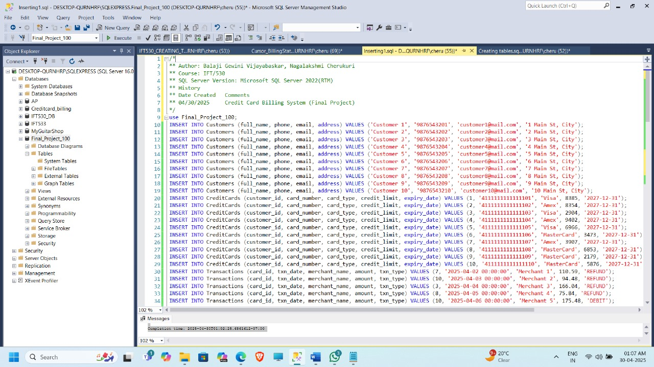

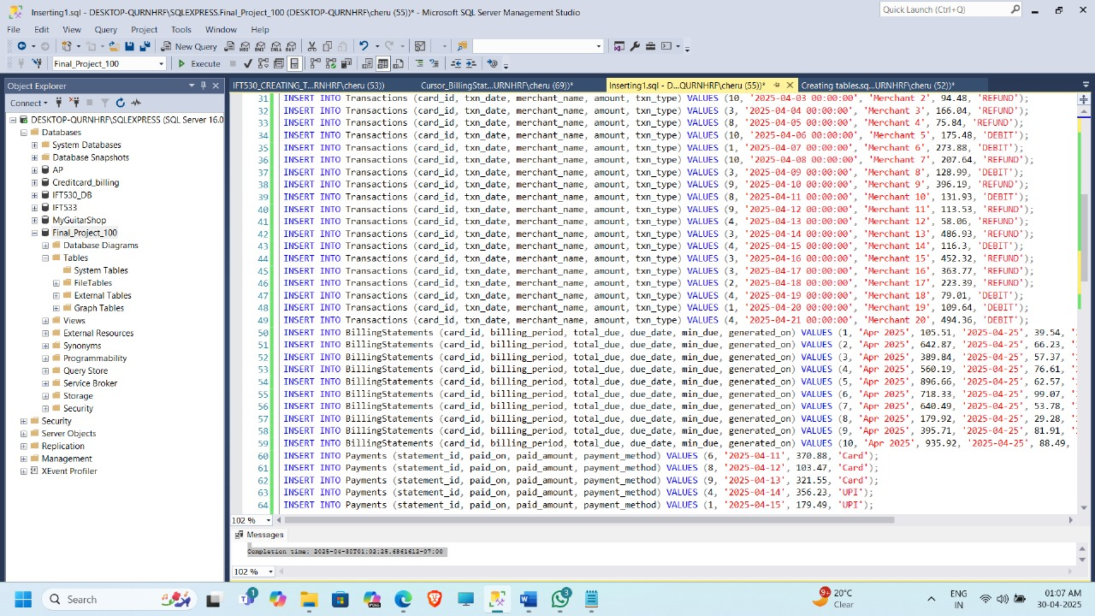

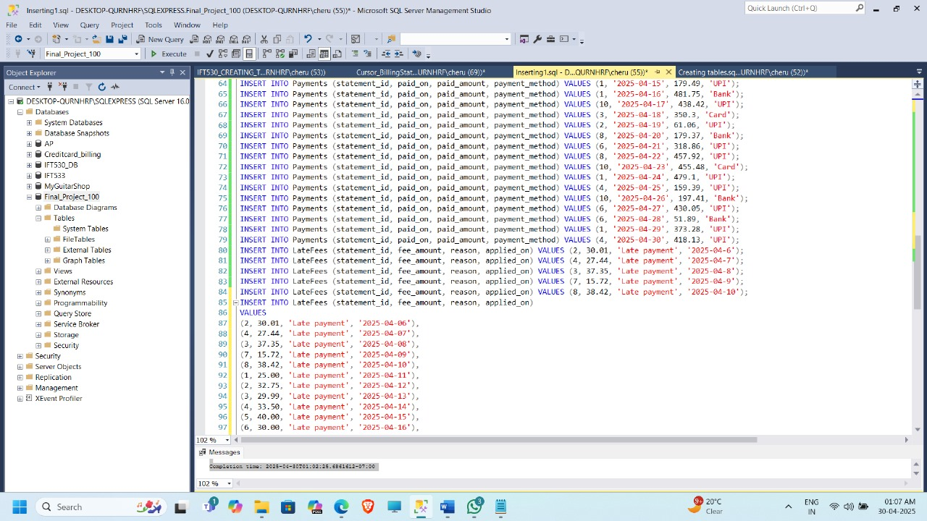

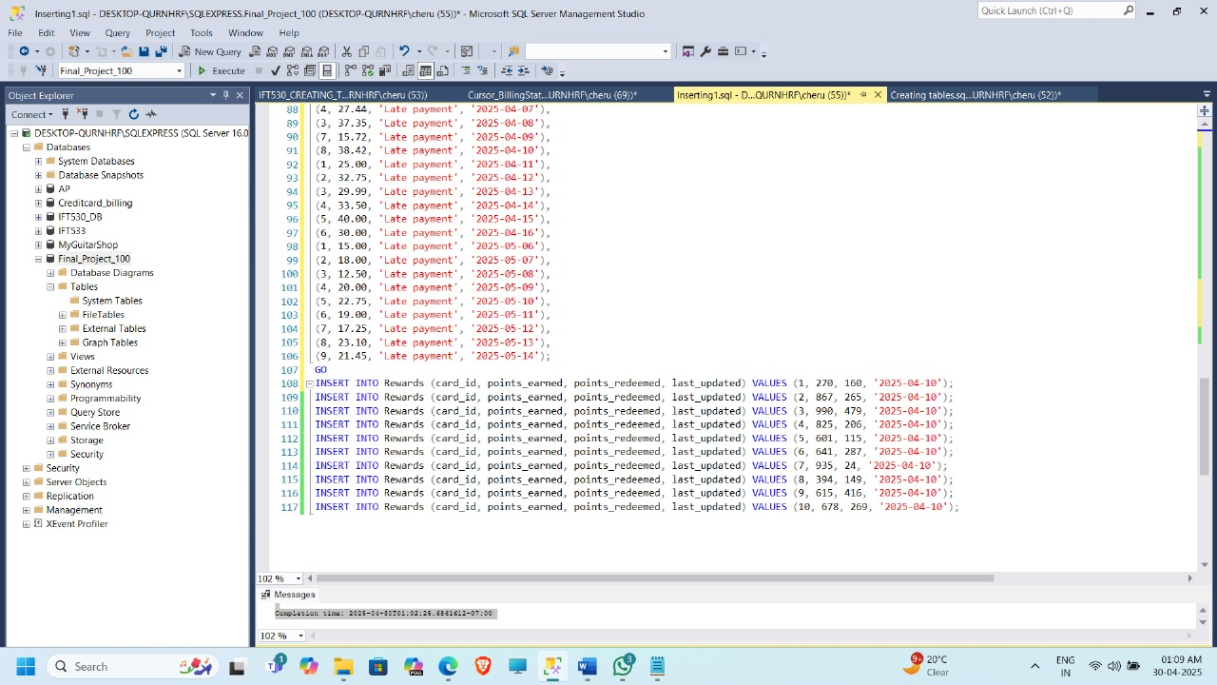

‘Create three queries and convert them into views’

‘code’

/*

** Author: Balaji Gewini Vijayabaskar, Nagalakshmi Cherukuri

** Course: IFT/530

** SQL Server Version: Microsoft SQL Server 2022(RTM)

** History

** Date Created Comments

** 04/30/2025 Credit Card Billing System (Final Project)

*/

USE Final_Project_100;

-- Drop existing views if they exist

IF OBJECT_ID('vw_HighOutstandingBalances', 'V') IS NOT NULL

DROP VIEW vw_HighOutstandingBalances;

GO

CREATE VIEW vw_HighOutstandingBalances AS

SELECT

c.full_name,

cc.card_number,

bs.billing_period,

bs.total_due

FROM

Customers c

JOIN CreditCards cc ON c.customer_id = cc.customer_id

JOIN BillingStatements bs ON cc.card_id = bs.card_id

WHERE

bs.total_due > 500;

GO

SELECT * FROM vw_HighOutstandingBalances;

GO

-- View 2: Recent Late Fees

IF OBJECT_ID('vw_RecentLateFees', 'V') IS NOT NULL

DROP VIEW vw_RecentLateFees;

GO

CREATE VIEW vw_RecentLateFees AS

SELECT

c.full_name,

cc.card_number,

bs.billing_period,

lf.fee_amount,

lf.applied_on

FROM

Customers c

JOIN CreditCards cc ON c.customer_id = cc.customer_id

JOIN BillingStatements bs ON cc.card_id = bs.card_id

JOIN LateFees lf ON bs.statement_id = lf.statement_id

WHERE

lf.applied_on >= DATEADD(DAY, -30, GETDATE());

GO

SELECT * FROM vw_RecentLateFees;

GO

-- View 3: Reward Summary

IF OBJECT_ID('vw_RewardSummary', 'V') IS NOT NULL

DROP VIEW vw_RewardSummary;

GO

CREATE VIEW vw_RewardSummary AS

SELECT

c.full_name,

cc.card_number,

r.points_earned,

r.points_redeemed,

(r.points_earned - r.points_redeemed) AS remaining_points

FROM

Customers c

JOIN CreditCards cc ON c.customer_id = cc.customer_id

JOIN Rewards r ON cc.card_id = r.card_id

WHERE

r.points_earned > 0;

GO

SELECT * FROM vw_RewardSummary;

GO

View 1 :

Explanation of Usefulness:

This view filters for customers owing more than $500, enabling: Follow-up to be given priority in collections units. Customer debt trends to be tracked by risk analysts. Customer service teams to step in proactively to ask for payment support or restructuring plans.

‘Image’

View 2 :

Explanation of Usefulness

This perspective calls out customers who have recently incurred late fees. It is valuable to: Customer service representatives to notify and educate customers about charges. Operations teams to measure whether payment reminders are working. Management to track trends in late payments and plan for optimization.

View 3 :

Explanation of Usefulness:

This view presents a clean picture of a customer's reward position. It can be used by: Marketing teams to market highest reward earners for promotions. Customers (via dashboards) to track and redeem points. Finance to predict reward liabilities.

‘Create an audit table:’

‘code’

/*

** Author: Balaji Gewini Vijayabaskar, Nagalakshmi Cherukuri

** Course: IFT/530

** SQL Server Version: Microsoft SQL Server 2022(RTM)

** History

** Date Created Comments

** 04/30/2025 Credit Card Billing System (Final Project)

*/

USE Final_Project_100;

GO

-- Step 1: Create the Audit Table

IF OBJECT_ID('Rewards_Audit', 'U') IS NOT NULL

DROP TABLE Rewards_Audit;

GO

CREATE TABLE Rewards_Audit (

audit_id INT IDENTITY(1,1) PRIMARY KEY,

reward_id INT,

card_id INT,

points_earned INT,

points_redeemed INT,

last_updated DATE,

action_type VARCHAR(10), -- 'INSERT', 'UPDATE', 'DELETE'

changed_on DATETIME DEFAULT GETDATE()

);

GO

-- Step 2: Create Trigger for INSERT

IF OBJECT_ID('trg_Reward_Insert', 'TR') IS NOT NULL

DROP TRIGGER trg_Reward_Insert;

GO

CREATE TRIGGER trg_Reward_Insert

ON Rewards

AFTER INSERT

AS

BEGIN

INSERT INTO Rewards_Audit (reward_id, card_id, points_earned, points_redeemed, last_updated, action_type)

SELECT reward_id, card_id, points_earned, points_redeemed, last_updated, 'INSERT'

FROM inserted;

END;

GO

-- Step 3: Create Trigger for UPDATE

IF OBJECT_ID('trg_Reward_Update', 'TR') IS NOT NULL

DROP TRIGGER trg_Reward_Update;

GO

CREATE TRIGGER trg_Reward_Update

ON Rewards

AFTER UPDATE

AS

BEGIN

INSERT INTO Rewards_Audit (reward_id, card_id, points_earned, points_redeemed, last_updated, action_type)

SELECT reward_id, card_id, points_earned, points_redeemed, last_updated, 'UPDATE'

FROM inserted;

END;

GO

-- Step 4: Create Trigger for DELETE

IF OBJECT_ID('trg_Reward_Delete', 'TR') IS NOT NULL

DROP TRIGGER trg_Reward_Delete;

GO

CREATE TRIGGER trg_Reward_Delete

ON Rewards

AFTER DELETE

AS

BEGIN

INSERT INTO Rewards_Audit (reward_id, card_id, points_earned, points_redeemed, last_updated, action_type)

SELECT reward_id, card_id, points_earned, points_redeemed, last_updated, 'DELETE'

FROM deleted;

END;

GO

-- Step 5: Test Scripts

-- Insert new reward (will trigger INSERT)

INSERT INTO Rewards (card_id, points_earned, points_redeemed, last_updated)

VALUES (1, 100, 10, '2025-04-28');

-- Update reward (will trigger UPDATE)

UPDATE Rewards

SET points_earned = 10

WHERE card_id = 1;

-- Delete reward (will trigger DELETE)

DELETE FROM Rewards

WHERE card_id = 1;

-- View audit logs

SELECT * FROM Rewards_Audit;

GO

‘image’

‘stored procedures and User Defined Function’

‘code:’

/*

** Author: Balaji Gewini Vijayabaskar, Nagalakshmi Cherukuri

** Course: IFT/530

** SQL Server Version: Microsoft SQL Server 2022(RTM)

** History

** Date Created Comments

** 04/30/2025 Credit Card Billing System (Final Project)

*/

USE Final_Project_100;

GO

-- USER DEFINED FUNCTION: Get Total Rewards by Card ID

IF OBJECT_ID('dbo.fn_GetTotalRewardPoints', 'FN') IS NOT NULL

DROP FUNCTION dbo.fn_GetTotalRewardPoints;

GO

CREATE FUNCTION dbo.fn_GetTotalRewardPoints (@card_id INT)

RETURNS INT

AS

BEGIN

DECLARE @totalPoints INT;

SELECT @totalPoints = ISNULL(SUM(points_earned - points_redeemed), 0)

FROM Rewards

WHERE card_id = @card_id;

RETURN @totalPoints;

END;

GO

-- STORED PROCEDURE: Get Customer Billing Summary

IF OBJECT_ID('dbo.sp_GetCustomerBillingSummary', 'P') IS NOT NULL

DROP PROCEDURE dbo.sp_GetCustomerBillingSummary;

GO

CREATE PROCEDURE dbo.sp_GetCustomerBillingSummary

@customer_id INT

AS

BEGIN

SELECT

c.full_name,

cc.card_number,

bs.billing_period,

bs.total_due,

bs.min_due,

bs.due_date

FROM Customers c

JOIN CreditCards cc ON c.customer_id = cc.customer_id

JOIN BillingStatements bs ON cc.card_id = bs.card_id

WHERE c.customer_id = @customer_id;

END;

GO

-- TESTING

-- Test the UDF

SELECT dbo.fn_GetTotalRewardPoints(0) AS TotalRewardPoints;

GO

-- Test the stored procedure

EXEC dbo.sp_GetCustomerBillingSummary @customer_id = 1;

GO

‘Image:’

‘cursor for your database.’

‘code:’

/*

** Author: Balaji Gewini Vijayabaskar, Nagalakshmi Cherukuri

** Course: IFT/530

** SQL Server Version: Microsoft SQL Server 2022(RTM)

** History

** Date Created Comments

** 04/30/2025 Credit Card Billing System (Final Project)

*/

USE Final_Project_100;

GO

-- CURSOR: Print all billing statements with total_due > 0

-- DROP existing procedure if it exists

IF OBJECT_ID('dbo.sp_ProcessBillingDue', 'P') IS NOT NULL

DROP PROCEDURE dbo.sp_ProcessBillingDue;

GO

-- CREATE procedure that uses a CURSOR

CREATE PROCEDURE dbo.sp_ProcessBillingDue

AS

BEGIN

DECLARE @statement_id INT,

@total_due DECIMAL(10,2),

@due_date DATE;

DECLARE billing_cursor CURSOR FOR

SELECT statement_id, total_due, due_date

FROM BillingStatements

WHERE total_due > 150;

OPEN billing_cursor;

FETCH NEXT FROM billing_cursor INTO @statement_id, @total_due, @due_date;

WHILE @@FETCH_STATUS = 0

BEGIN

PRINT 'Statement ID: ' + CAST(@statement_id AS VARCHAR) +

' | Due: $' + CAST(@total_due AS VARCHAR) +

' | Due Date: ' + CAST(@due_date AS VARCHAR);

-- You can also add logic to send alerts, update flags, etc. here.

FETCH NEXT FROM billing_cursor INTO @statement_id, @total_due, @due_date;

END

CLOSE billing_cursor;

DEALLOCATE billing_cursor;

END;

GO

-- Run the procedure to test the cursor

EXEC dbo.sp_ProcessBillingDue;

GO

‘Image’

